**VNM Pedal user manual**

# **1. Pedal controller and its configuration**

## **1.1. Pedal controller**

VNM pedal controller has 4 GX12-4P connections for throttle, brake, clutch and handbrake. Throttle and clutch use potentiometer for linearity while brake and handbrake can be loadcell signal (default) or analog signal. User can change the input of brake/handbrake by changing jumps in controller

Pls note: Put the switch on the controller in “Run” to use pedal, if it is in “DFU”, the controller is in DFU mode to upgrade firmware

## **1.2. Pedal configuration overview**

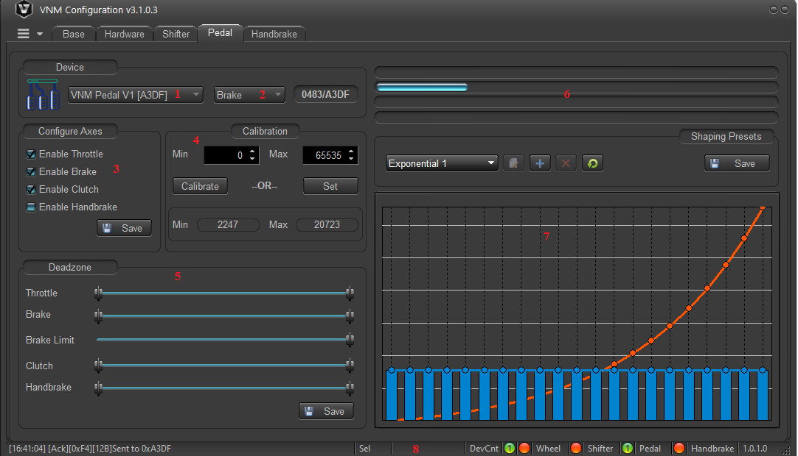

1 – Select pedal: choose pedal to communicate.

2 – Select axis: Choose an axis to communicate (throttle, brake, clutch, handbrake)

3 – Configure axes: Enable/disable axes. Default handbrake is disable.

4 – Calibrate area: Is used to setup min-max value after upload firmware.

5 – Deadzone: setup min-max deadzone and brake limit

6 – Progress bars: visualize current value of axes.

7 – Shaping presets: used to adjust pedal curve.

8 – Staus bar: show pedal connection status and firmware version

### **1.2.1. Select pedal**

VNM pedal or VNM FFB controller could be chosen here.

### **1.2.2. Select axes**

Choose which axes you want to calibrate or set shaping preset.

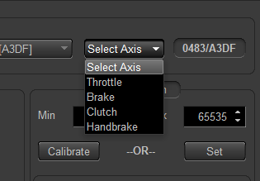

### **1.2.3. Configure axes**

Pedal controller supports 4 axes: throttle, brake, clutch and handbrake. Tick to checkboxes to enable and click save. handbrake is disable by default

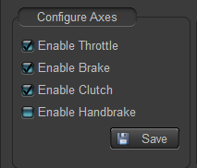

### **1.2.4. Calibration**

Calibration is used to determine minimum and maximum value of each axis. You must choose which axis to configure.

User can click “calibrate” (it will change to “finish”) and push the axis to the position that user want and click “finish” or user can set min-max value by entering value from 0 to 65535 and click “set” too.

### 1.2.5. Deadzone

A ‘Deadzone’ is a term used to describe an unregistered percentage of pedal application. A deadzone can either be at the beginning of the pedal press or the end of the pedal press. User can slice tracker along the bar.

Brake limit: In I-racing, user don’t want to brake goes up 100%, you can set a maximum value that brake can go up in brake limit bar.

After finishing, click “save” button in this area.

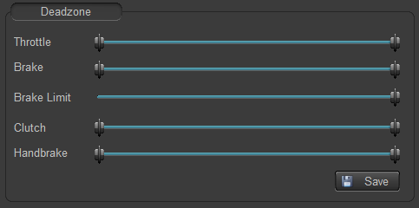

### 1.2.6. Progress bar

These progress bars visualize current value of throttle, brake, clutch, handbrake corresponding high bar to low bar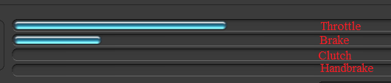

### 1.2.7. Shaping preset

In this area, user must select an axis to configure first.

* 1: Select preset: User can choose which preset is applied to the axis. it has some default presets at the beginning.
* 2: User can add new preset
* 3: user can delete a preset
* 4: get the axes’ current preset from firmware.
* 5: user can move dots up and down to create a preset
* 6: the bar graph show last 20 previous values of the axis.

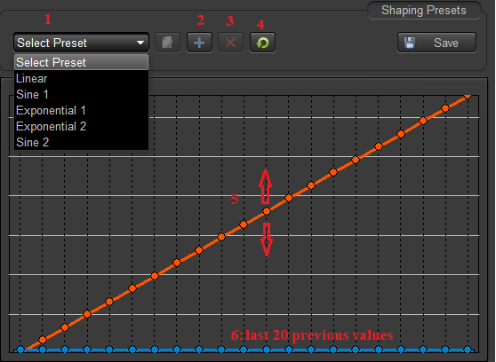

### 1.2.8. Status bar

* 1: indicates that pedal is connected or not (green is connected, orange is disconnected) and number of pedal connected is shown in green dot.
* 2: shows the firmware version

